Student Learning Objective

Student Learning Objective Form (Teacher or Support Professional)
Student Learning Objective Title:____________English 101 Unit 2 (Life - Pre-Intermediate)____________
Student Learning Objective Grade Level(s) University Undergraduate - First Year
Pre-K | K | 1 | 2 | 3 | 4 | 5 | 6 | 7 | 8 | 9 | 10 | 11 | 12

Content Area: | Art | ELA/English | ESL | Mathematics | Music
Physical Education | Science | Social Studies | World Languages | Other:_______________________
Number of Students:____75_____________________________________
Interval of Instruction (select one): Semester (2nd month) School Year Other (Please specify):

Priority of Content
Essential Question: What is the most important knowledge/skill(s) I want my students to attain by the end of the interval of instruction?

Objective Statement:
Students will know and be able to use language for talking about their interests in the form of a social club and recommending/encouraging people to join. They will be able to produce an attractive and persuasive written, drawn, or printed advertisement for a social club of their own creation related to their interests, including all the necessary components, with correct spelling, punctuation, and appropriate layout.

Rationale:
“Students enrolled in Fundamental English 1 at Chiang Mai University in Chiang Mai Thailand, will be studying Unit 2 in their course book entitled Life Pre-Intermediate (2012). From the several standards which encompass the unit to be taught, three are associated with a performance task that can and will be assessed using a rubric… The goal for this rubric assessed task is to consolidate and practice learned language for “talking about interests” and “recommending and encouraging people to do things” (Hughes et al., 2012, p. 32)” (Kinney, 2018)
Aligned Standards:
“The Life Pre-intermediate book has been mapped to the Common European Framework of Reference (CEFR) and covers the majority of competencies for CEFR level B1, “threshold” level, whose primary descriptor is “students at this level can maintain conversations. (Sayer, n.d.).” (Kinney, 2018). The objective related assessed exercise “Advertising for Members” was mapped against the descriptors for B1, and the associated CEFR standards with components and descriptors for the task are as follows:

CEFR Standards for exercise 2e Advertising for Members (page 29)
Component | Descriptor
1. Overall reading comprehension | Can read straightforward factual texts on subjects related to his/her field and interest with a satisfactory level of comprehension.
2. Orthographic control | Can produce continuous writing, which is generally intelligible throughout. Spelling, punctuation and layout are accurate enough to be followed most of the time.
3. Overall written production | Can write straightforward connected texts on a range of familiar subjects within his/her field of interest, by linking a series of shorter discrete elements into a linear sequence.
Note. LIFE Pre-intermediate CEF mapping Framework level: B1 for exercise 2e “Advertising for members” (Hughes et al., 2012, p. 29). Adapted from Life Pre-Intermediate and the Common European Framework of Reference by Sayer, M., n.d., p. 11.

Essential Question: Where are my students now (at the beginning of instruction) with respect to the objective?

Baseline Data:
No baseline data is available for current students with regard to the standards associated with this task; and since the objectives only partially cover one unit, there will be no pre-test from which to gather data. Therefore, Adverts from the previous year students were graded using the rubric established for this task (see Figure A) and the results of four sections (30 groups) were tabulated in the following chart:

2e - Advertising for Members
2017 Term 1 | Section 12 | Section 21 | Section 29 | Section 36
Group 1 | Harry Potter Club  2-2-3=7 | Swimming Club  3-3-3-9 | Relaxing Club  2-2-3=7 | Music Lover's Club  3-2-3=8
Group 2 | Cinema Club  3-2-3=8 | Beverage Club  2-3-2=7 | Eating Club  3-3-3=9 | Movie Club  2-3-3=8
Group 3 | Bird Watching Club  2-2-2=6 | Movie Club  3-2-3=8 | Cat Lover's Club  3-2-3=8 | Astronomy Club  3-3-3=9
Group 4 | Potluck Club  2-2-3=7 | Cooking Club  3-3-3=9 | Heavy Metal Club  2-2-1=5 | Gaming Club  2-3-3=8
Group 5 | Movie Club  3-3-3=9 | Eating Club  3-3-2=8 | BB Gun Club  2-2-3=7 | Canine Club  3-2-3=8
Group 6 |  | Zumba Club  2-3-3=8 | Sleepin' Club  3-3-3=9 | Plant Club  3-3-3=9
Group 7 |  | Sleeping Club  1-3-1=5 | Boxing Club  3-3-3=9 | Movie Addict Club  3-2-3=8
Group 8 |  | Walking Club  3-3-2=8 | Touring Club  2-3-2=7
Group 9 |  | Movie Culb (sic)  3-2-3=8 | Comedy Club  2-3-2=7
Averages | 37/5 = 7.4 | 70/9 = 7.8 | 68/9 = 7.6 | 58/7 = 8.3
Score Key: content (3) - correctness (3) - attractiveness (3) = total (9)
Target = 8 | Met Target = 20 (66.6%) |  | Did Not Meet = 10 (33.3%)

- The scores for each of the rubric criteria were recorded and summed for a total out of 9 possible points for each group.
- The scores for each of the four sections were then averaged to provide a baseline, with an average of all groups at 7.8.

Rigor of Target
Essential Question: Based on what I know about my students, where do I expect them to be by the end of the interval of instruction and how will they demonstrate their knowledge and skills?

Target(s):
80% of groups will receive a score of at least 8 on the performance task.
- An acceptable target for this SLO has been determined as a score of 8 points out of 9 possible on the “Advertising for Members” task (2e), according to the rubric developed for that task (see Figure A).
- At least 80% of the current term groups are expected to reach or exceed the target.
- Results of the current term task assessment will be tabulated on the same chart used here for baseline data, and appended to this SLO for final evaluation (see Figure B)

Rationale for Target(s):
- This target was chosen based on the baseline data of 30 groups from the previous year scoring an average of 7.8 with 20 groups at or above the 8 point target and 10 groups below the target.
- 66.6% of groups reached or exceeded the 8 point target last year, making this years goal of 80% an ambitious one.
- The goal is considered attainable due to the extra support that this year’s students will have in the form of the rubric being provided before work on the task begins.
- The target for this task is not tiered due to the nature of the task being group work and no useful data on individual students being produced, nor baseline data for individual students related to the standards available.

Quality of Evidence

Evidence Source(s):
“The performance task to be assessed is exercise number 2e in the Life Pre-Intermediate book, entitled “advertising for members” (Hughes et al., 2012, p. 29). This task will be done in groups and require the creation of an imaginary social club and a corresponding advert with the intent to recruit members.” (Kinney, 2018).
This assessment is appropriate because it requires understanding and application of the content and standards components in order to create the performance task product (the club advert).
The task will be evaluated twice, in class. Firstly, the students will self-assess using the supplied rubric after creation of the first draft and record their scores. Then, after working through the supplied Self-Assessment/Goal-Setting (SA/GS) and Error Analysis (EA) Worksheets, students will edit and complete their final draft which will be assessed with the same rubric by the teacher as well as peer-assessed by other students as the communicative purpose part of the task to decide which club that they would like to join and be able to write two sentences using learned language and giving an objective reason for their choice with evidence from their assessment. The peer-assessment is to be used as feedback, while the teacher assessment data will be gathered and recorded for use with this SLO. Scores will also be recorded and graphed by students, along with their determined goals and strategies for improvement, on a supplied Progress Tracking (PT) worksheet to improve self-regulation and provide a visual representation of their learning progress.

Approval of Objective (Completed by the Evaluator)
Priority of Content Circle one: | Acceptable Needs Revision
Rigor of Target Circle one: | Acceptable Needs Revision
Quality of Evidence Circle one: | Acceptable Needs Revision

Notes:
References

Hughes, J., Stephenson, H., & Dummett, P. (2012). Life Pre-Intermediate. National Geographic Learning. Andover, UK.
Kinney, J. (August, 2018). Performance Rubric. OTL547 – Evaluation and Assessment. Colorado State University – Global Campus. Greenwood Village, CO.
Sayer, M. (n.d.). Life Pre-Intermediate and the Common European Framework of Reference. National Geographic Learning. Retrieved from http://www.ngllife.com/sites/default/files/LIFE_Pre-intermediate.zip

Results

Proficiency Target: 8/9 points (80% of groups)
Proficiency Achievement: 94% of groups met or exceeded target
Analysis of Student Performance Data
After the performance task assessment, feedback was given to the groups on their work and rubric derived scores for both the first and final drafts were recorded for analysis. The SA/GS, EA, and PT worksheets that had been completed by students electronically using copies of the original Google Doc were also collected via online submission to examine for common problems or misconceptions. Samples of the worksheets completed by one group of students can be found in Figures C, D and E with the students’ writing in orange. The first and final drafts of the performance task (the club advert) made by the same group of students can be found in the left and right columns of Figure F, respectively. The students’ work on the worksheets shows a satisfactory understanding of the process and is more or less representative of the other groups’ completed worksheets. Some groups did not complete their worksheets before the final advert draft was due, but they did finish the advert to be assessed along with the others. Interestingly, though as could be expected, all of the groups who received less than a full final score of 9 on their final drafts were among those groups who did not finish their worksheets; in other words, all of the groups who finished their worksheets earned a full score of 9 on their final adverts.
Figure B shows the first and final draft scores for each group in each of the two sections. The improvement between drafts is clear to see with only 1 out of the 17 groups meeting the target (that was set in Module 3) of 8 on the first draft; while 16 of 17 groups met the target for the final draft (see Figure B). The radar chart in Figure G shows the consistent improvement among nearly all groups with only 1 group showing no improvement related to the criteria on the rubric. The group without improvement was among those groups that didn’t complete their worksheets.
This year’s data was compared to last year’s, when no rubric or self-assessment process worksheets were used, to determine if there was a significant difference in achievement that could be attributed to the change in methods (see Figure H). The graph shows a nearly 28% increase from 2017 to 2018 in groups meeting the goal of at least 8/9 points based on the rubric criteria. In light of the results showing nearly all groups meeting the achievement target, and the groups that made use of the rubric, SA/GS, and EC worksheets all garnering full scores of 9/9, the standards and criteria assessed in this task seem to be sufficiently mastered to move on to the next concept. If time allowed, the groups that didn’t complete the worksheets or didn’t achieve full scores could be asked to apply the feedback that was given and revise their adverts after completing the worksheets for a reassessment. This action would be commensurate with the mastery learning paradigm as noted by Guskey (2010) ”after corrective activities, mastery learning teachers give students a second, parallel formative assessment that helps determine the effectiveness of the corrective instruction and offers students a second chance to demonstrate mastery and experience success.”
Summary:
The proficiency target has been achieved and the standards sufficiently mastered by the students to move on to the next concept. As noted in the analysis, all but one group achieved the target set for the task by using the rubric, and every group that completed the worksheets received a full 9/9 score. The results show a marked improvement over the previous year, possibly attributable to the students’ use of the rubric and supplied worksheets.

Reference

Guskey, T. R. (October, 2010). Interventions That Work: Lessons of Mastery Learning. Educational Leadership. Volume 68, Number 2. Pages 52-57. Retrieved from http://www.ascd.org/publications/educational-leadership/oct10/vol68/num02/Lessons-of-Mastery-Learning.aspx

Figures

Figure A
Task Performance Rubric - Advertising for Members
(9 points possible)
Criteria | Proficient  (great = 3) | Acceptable  (good = 2) | Limited  (poor = 1)
Content  Includes all necessary components | - contains all items:  - headline  - benefits  - prize/gift/etc.  - important information like dates/times/location, etc.  - design elements: pictures/images/drawing/colors/etc. | missing 1 or 2 items:  - headline  - benefits  - prize/gift/etc.  - important information like dates/times/location, etc.  - design elements: pictures/images/drawing/colors/etc. | missing 3 or more:  - headline  - benefits  - prize/gift/etc.  - important information like dates/times/location, etc.  - design elements: pictures/images/drawing/colors/etc.
Grammar  Spelling, punctuation, and layout are correct | - All words spelled correctly.  - All necessary punctuation included and used correctly.  - Appropriate layout: headings, body, lists, details, information, and pictures all in logical position and sequence. | - most words spelled correctly  - most necessary punctuation included and used correctly  - layout: headings, body, lists, details, information, and pictures mostly in logical position and sequence (a few errors or misplaced elements) | - many words spelled incorrectly  - little or no necessary punctuation included  - inappropriate layout: headings, body, lists, details, information, and pictures in illogical positions and sequence
Design  Advert is attractive and persuasive | - Design is attractive and unique.  - All questions, descriptions, and information are easy to understand.  - Benefits and reasons for joining are convincing. | - design is attractive or unique, but not both  - details and information mostly easy to understand  - reasons for joining are mostly convincing | - design is sloppy with little effort given  - mostly confusing details and information  - reasons for joining are unconvincing

Figure B
2e - Advertising for Members
 | First Draft |  | Final Draft
2018 Term 1 | Section 12 | Section 21 | Section 12 | Section 21
Group 1 | Acoustic Music Club - 5 | Board Games Club - 6 | Acoustic Music Club - 9 | Board Games Club - 9
Group 2 | Harmony Music Club - 6 | Enjoy Eating Club - 7 | Harmony Music Club - 8 | Enjoy Eating Club - 9
Group 3 | Board Game Club - 6 | Veggie Club - 6 | Board Game Club - 9 | Veggie Club - 9
Group 4 | Napping Club - 7 | Sloth Sleeping Club - 7 | Napping Club - 9 | Sloth Sleeping Club - 9
Group 5 | E-Sport Club - 1 | Movie Club - 7 | E-Sport Club - 9 | Movie Club - 8
Group 6 | Master Chef Club - 7 | Want to Sing Club - 7 | Master Chef Club - 9 | Want to Sing Club - 7
Group 7 | Dance Club - 8 | Eating Club - 7 | Dance Club - 9 | Eating Club - 9
Group 8 | Cook It Club - 6 | Joy of Eating Club - 5 | Cook It Club - 9 | Joy of Eating Club - 8
Group 9 | Music Club - 5 |  | Music Club - 8
Averages | 51/9 = 5.7 | 52/8 = 6.5 | 79/9 = 8.8 | 68/8 = 8.5
Score Key: content - correctness - attractiveness = total
Target = 8 | Met Target = 1/17 (5.9%) |  | Met Target = 16/17 (94.1%)
Avg. = 8.6 | Did Not Meet = 16/17 (94.1%) |  | Did Not Meet = 1/17 (5.9%)

Figure C
Name of Club  Dance Club | Group member names  - Fallon  - Sammy  - Anna  - Andre  - Frank

Self-Assessment and Goal-Setting (Student Example)
Self-Assessment and Goal-Setting Worksheet - Advertising for Members - With Examples
(For Use with Task Performance Rubric)
Draft Score  8 | Proficient Performance  (Objectives)  “what is expected” | Areas of Strength  (Successes)  “what we are doing well” | Areas for Growth  (Goals)  “what we need to improve”
Content  Includes all necessary components | contains all items:  - headline  - benefits  - prize/gift/etc.  - important information like dates/times/location, etc.  - design elements: pictures/images/drawing/colors/etc. | - We described the benefits of joining out dance club well  - The date, time and place are on our poster. | - We need to inform the kind of songs and choreographies.
Grammar  Spelling, punctuation, and layout are correct | - All words spelled correctly.  - All necessary punctuation included and used correctly.  - Appropriate layout: headings, body, lists, details, information, and pictures all in logical position and sequence. | - We arranged the sentence structure in appropriate order.  - We spelled words correctly. | - The layout needs to be changed to make it easier to read.
Design  Advert is attractive and persuasive | - Design is attractive and unique.  - All questions, descriptions, and information are easy to understand.  - Benefits and reasons for joining are convincing. | - We added colors to the headline and texts.  - We also drew picture on it. | - We need to our poster design to look more attractive.  - We need to have some actual pictures of our club’s activities.

Figure D
Error Analysis (Student Example)
Error Analysis Worksheet - Advertising for Members - With Examples
(For Use with Self-Assessment and Goal-Setting Worksheet)
Final Score  9 | Proficient Performance  (Objectives)  “what is expected” | Identified Problems  (Errors)  “mistakes and omissions” | How to Fix the Problems  (Corrections)  “strategies for improvement”
Content  Includes all necessary components | contains all items:  - headline  - benefits  - prize/gift/etc.  - important information like dates/times/location, etc.  - design elements: pictures/images/drawing/colors/etc. | - We didn’t inform about songs and choreographies. | - We need to tell and give the examples of songs and choreographies.
Grammar  Spelling, punctuation, and layout are correct | - All words spelled correctly.  - All necessary punctuation included and used correctly.  - Appropriate layout: headings, body, lists, details, information, and pictures all in logical position and sequence. | - Our layout isn’t organized well enough such as the order of body. | - We should look to the examples of club’s posters as a model and try to rearrange our poster’s layout.
Design  Advert is attractive and persuasive | - Design is attractive and unique.  - All questions, descriptions, and information are easy to understand.  - Benefits and reasons for joining are convincing. | - The poster’s design isn’t attractive enough. | - We should make our poster more attractive by adding more color and giving an eye-catching motto.

Figure E
Progress Tracking (Student Example)
Progress Tracking Worksheet - Advertising for Members - With Examples
(For Use with Self-Assessment & Goal-Setting and Error Analysis Worksheets)
Areas for Growth  (Goals)  “what we need to improve” | How to Fix the Problems  (Corrections)  “strategies for improvement”
- We need to inform the kind of songs and choreographies.  - The layout needs to be changed to make it easier to read.  - We need to our poster design to look more attractive.  - We need to have some actual pictures of our club’s activities. | - We need to tell and give the examples of songs and choreographies.  - We should look to the examples of club’s posters as a model and try to rearrange our poster’s layout.  - We should make our poster more attractive by adding more color and giving an eye-catching motto.
Student Progress Chart

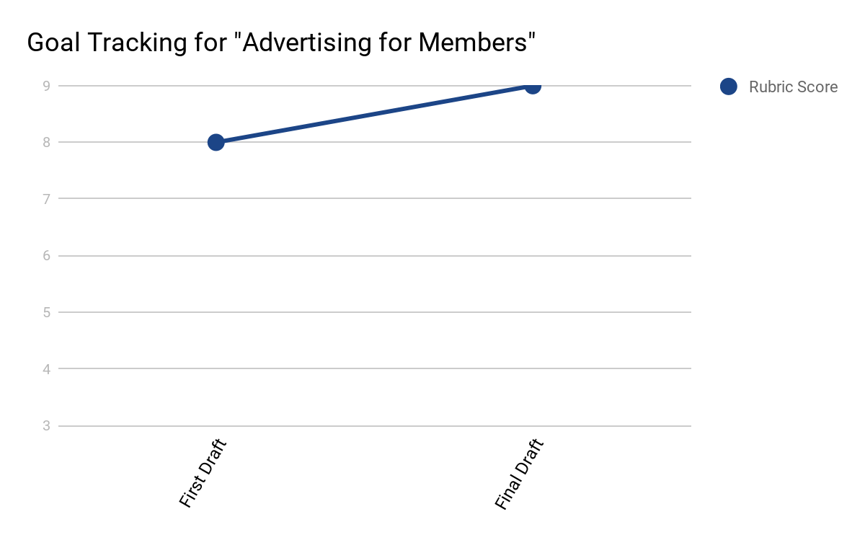

Figure F
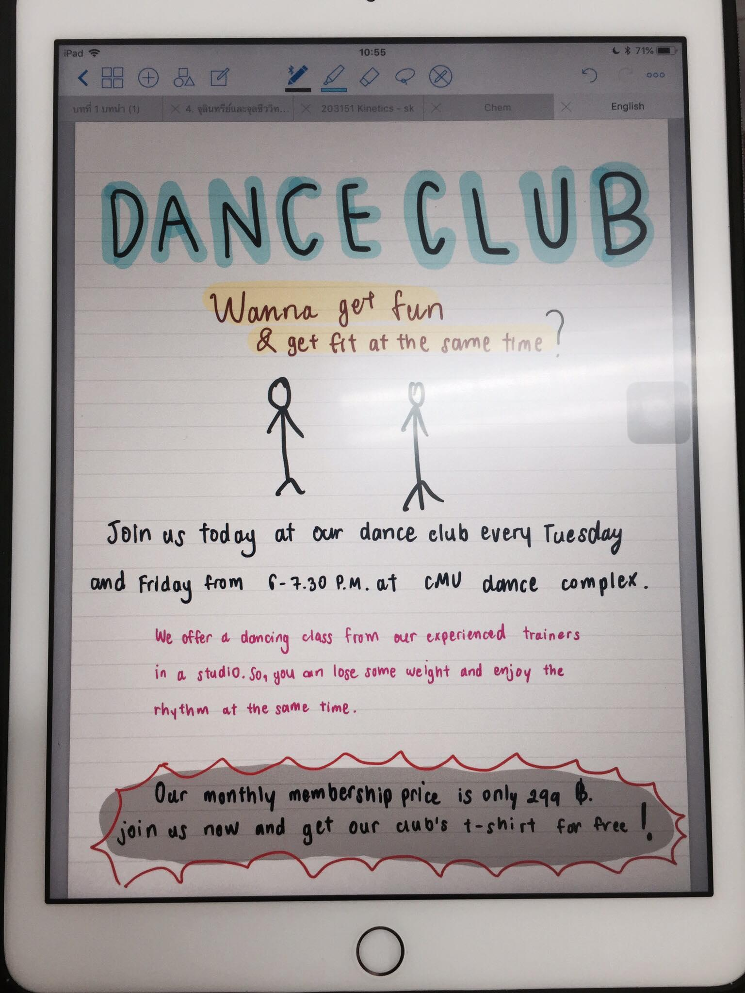 | 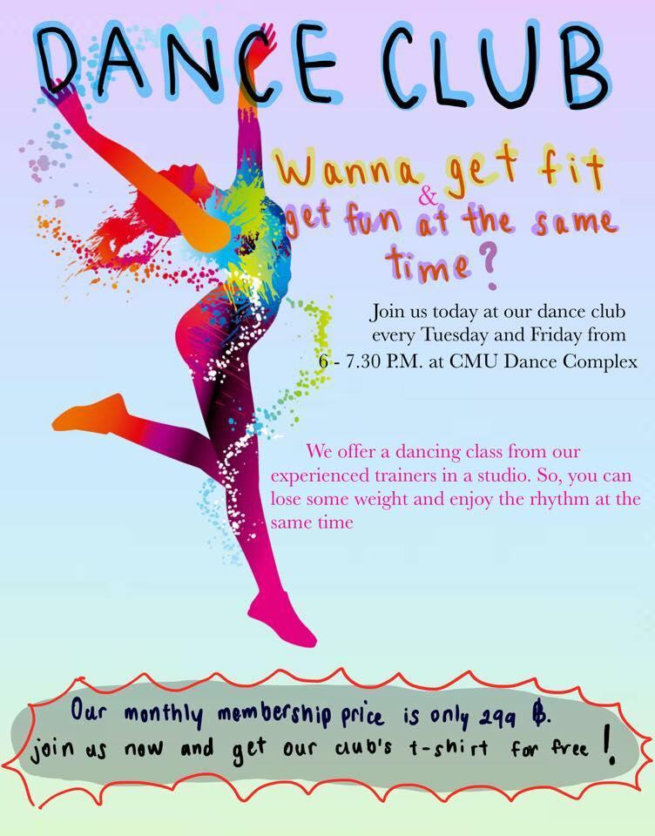

Figure G
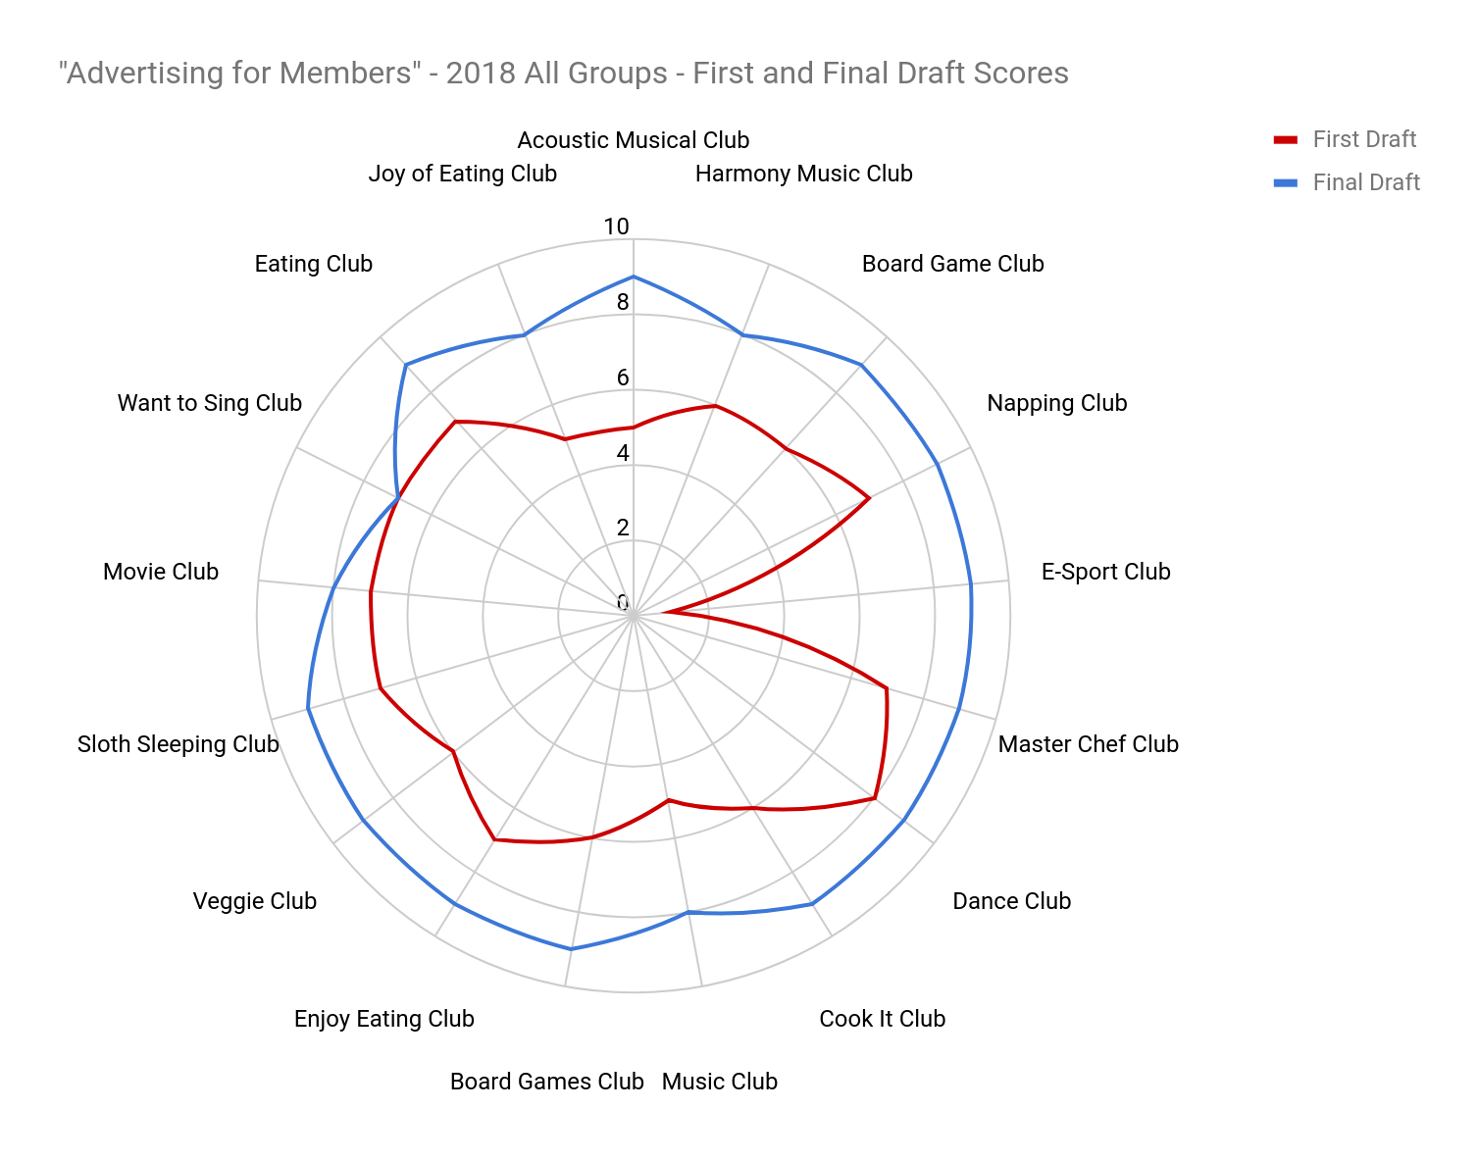

Figure H
